**Project Name:** Hotel Hospitality Project Using SQL & Power BI

**Dataset Link:** <https://drive.google.com/drive/folders/1ZRzYjs_vKwbliQBbb_mFQfoeUDSXH5_2?usp=sharing>

**ERD Diagram:**

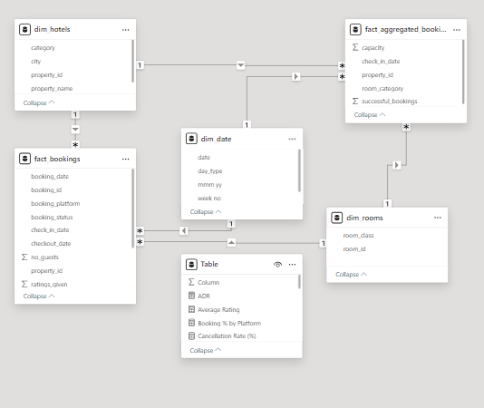

**#Total Revenue:**

SELECT SUM(revenue_realized)

AS total_revenue

FROM fact_bookings;



**#Total Bookings:**

SELECT COUNT(booking_id)

AS total_bookings

FROM fact_bookings;



**#Total Capacity:**

SELECT SUM(capacity)

AS total_capacity

FROM fact_aggregated_bookings;



**#Total Successful Bookings:**

SELECT SUM(successful_bookings)

AS total_successful_bookings

FROM fact_aggregated_bookings;

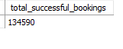

**#Occupancy Percentage:**

SELECT

SUM(successful_bookings) / SUM(capacity)

* 100 AS occupancy_percentage

FROM fact_aggregated_bookings;



**# Average Rating:**

SELECT

round( AVG(ratings_given) ,1)AS average_rating

FROM fact_bookings where ratings_given

is not null and ratings_given >0;

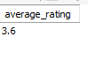

**#Total Cancellations and Cancellation Rate:**

SELECT

COUNT(*) AS total_cancelled_bookings,

round(COUNT(*) * 100.0 / (SELECT COUNT(*) FROM fact_bookings)) AS cancellation_rate

FROM fact_bookings

WHERE booking_status = 'Cancelled';

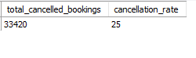

**#No Show Bookings and Rate:**

SELECT

COUNT(*) AS total_no_show_bookings,

round(COUNT(*) * 100.0 / (SELECT COUNT(*) FROM fact_bookings)) AS no_show_rate

FROM fact_bookings

WHERE booking_status = 'No show';

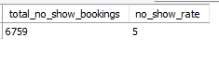

**#ADR**

SELECT SUM(revenue_generated)/

COUNT(booking_id) AS ADR

FROM fact_bookings

WHERE booking_status='Checked Out';



**#RevPAR (Revenue Per Available Room):**

SELECT SUM(revenue_realized) /

SUM(capacity) AS RevPAR

FROM fact_aggregated_bookings ab

JOIN fact_bookings fb ON

ab.property_id = fb.property_id;

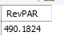

**#DBRN (Daily Booked Room Nights):**

SELECT SUM(successful_bookings) /

COUNT(DISTINCT check_in_date) AS DBRN

FROM fact_aggregated_bookings;

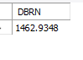

**#DSRN**

SELECT SUM(capacity) /

COUNT(DISTINCT check_in_date)

AS DSRN

FROM fact_aggregated_bookings;



**#DURN (Daily Utilized Room Nights):**

SELECT AVG(daily_checked_out_count) AS DURN

FROM (SELECT d.date,COUNT(*) AS daily_checked_out_count

FROM dim_date d JOIN fact_bookings fb

ON d.date = fb.checkout_date WHERE fb.booking_status =

'Checked Out'GROUP BY d.date) AS daily_counts;



**#Revenue by City:**

SELECT h.city, SUM(b.revenue_realized)

AS revenue_by_city

FROM fact_bookings b JOIN dim_hotels h

ON b.property_id = h.property_id

GROUP BY h.city;

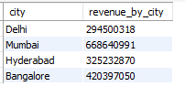

**#Occupancy % by City:**

SELECT h.city,SUM(ab.successful_bookings) /

SUM(ab.capacity) * 100 AS occupancy_by_city

FROM fact_aggregated_bookings ab

JOIN dim_hotels h ON ab.property_id =

h.property_id GROUP BY h.city;

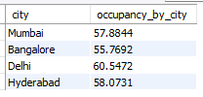

**#Average Rating by City:**

SELECT h.city,

round(AVG(b.ratings_given)) AS avg_rating_by_city

FROM fact_bookings b

JOIN dim_hotels h ON b.property_id = h.property_id

where b.ratings_given is not null and ratings_given>0

GROUP BY h.city;

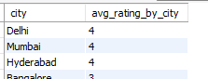

**-- Average Rating**

SELECT

d.week_no,

round(AVG(b.ratings_given),1) AS weekly_avg_rating

FROM fact_bookings b

JOIN dim_date d ON b.check_in_date = d.`date`

GROUP BY d.week_no

ORDER BY d.week_no;

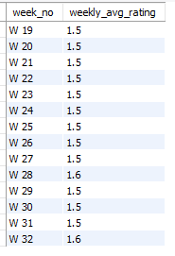

**# Booking % by Platform:**

SELECT booking_platform,

round(COUNT(*) * 100.0 / (SELECT COUNT(*)

FROM fact_bookings),1) AS booking_percentage

FROM fact_bookings

GROUP BY booking_platform;

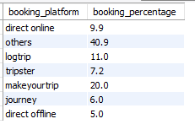

**#Citywise Cancellation %:**

WITH total_bookings_by_property AS (

SELECT property_id, COUNT(*) AS total_bookings

FROM fact_bookings

GROUP BY property_id

)

SELECT

h.city,

COUNT(*) * 100.0 / tb.total_bookings AS cancellation_percentage

FROM fact_bookings b

JOIN dim_hotels h ON b.property_id = h.property_id

JOIN total_bookings_by_property tb ON b.property_id = tb.property_id

WHERE b.booking_status = 'Cancelled'

GROUP BY h.city, tb.total_bookings;

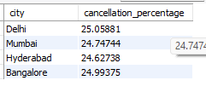

**#Popular Room Types by Number of Bookings:**

SELECT r.room_class,r.room_id,

COUNT(*) AS bookings_by_room_class

FROM fact_bookings b

JOIN dim_rooms r ON b.room_category = r.room_id

GROUP BY r.room_class,r.room_id

ORDER BY bookings_by_room_class DESC;

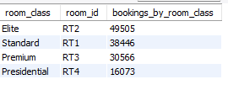

**Conclusion: Key Insights & Strategic Focus**

1. **Revenue Performance**:
   * **Total Revenue**: 2B INR over three months.
   * **Top Performers**: Luxury hotels contributed 61.61%, with "ITV Exotica" leading at 320M INR.
   * **Booking Impact**: 82.46% revenue from successful check-outs.
2. **Occupancy & Booking**:
   * **Average Occupancy**: 57.87%, with Mumbai at 24.92% and Hyderabad at 25%.
   * **Booking Channels**: 40.9% bookings via "others" (unspecified platforms).
3. **Stable Occupancy, Falling Revenue**:
   * **Insight**: Occupancy remained stable, but revenue decreased. This suggests hotels were making less money per booking. Consider strategies like adjusting prices or offering premium services.
4. **Cancellations**:
   * **Rate**: Overall 24.83%, highest in Delhi at 25.2%.
   * **Impact**: Significant revenue loss from cancellations.
5. **Customer Satisfaction**:
   * **Average Rating**: 3.60/5, highest in Delhi (3.8), lowest in Bangalore (3.4).
6. **Revenue Metrics**:
   * **ADR**: 14.92K INR, **RevPAR**: 8.63K INR, **Realization**: 70.15%.
7. **City-Wise Insights**:
   * **Revenue**: Mumbai leads with 39.13%.
   * **Occupancy by Day**: 74% on weekdays vs. 51% on weekends.

**Strategic Focus:**

* **Reduce Cancellations & Improve Satisfaction**: Focus on Bangalore.
* **Revenue Optimization**: Enhance ADR, RevPAR, and realization rates.
* **Operational Efficiency**: Leverage insights to regain market share.